**Dynamic Design Analysis of the Car System**

**For ECU 1:**

* *“Draw a state machine diagram for each ECU component.”*

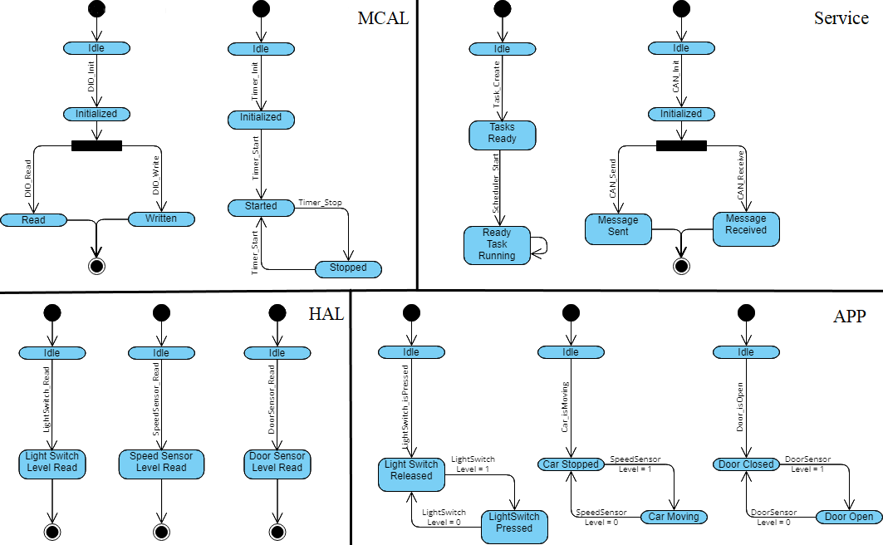

* *“Draw a state machine diagram for the ECU operation.”*

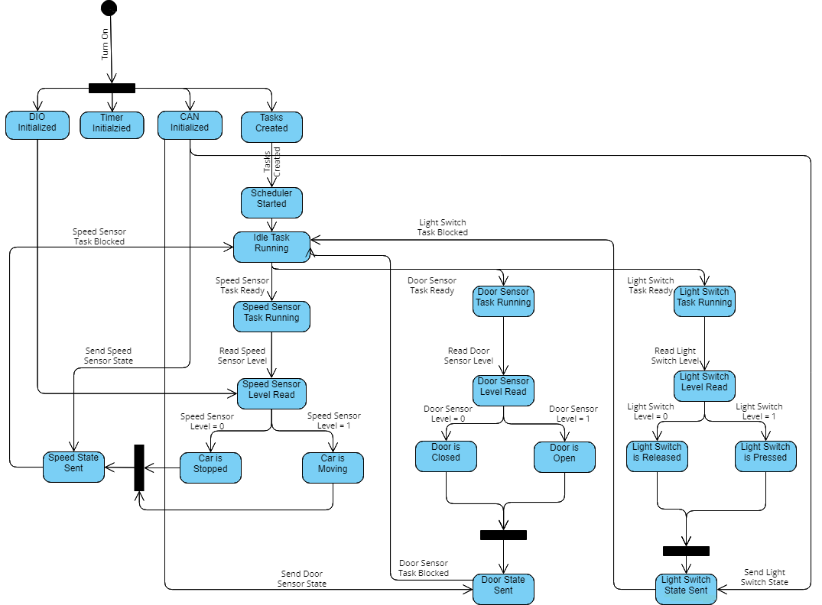

* *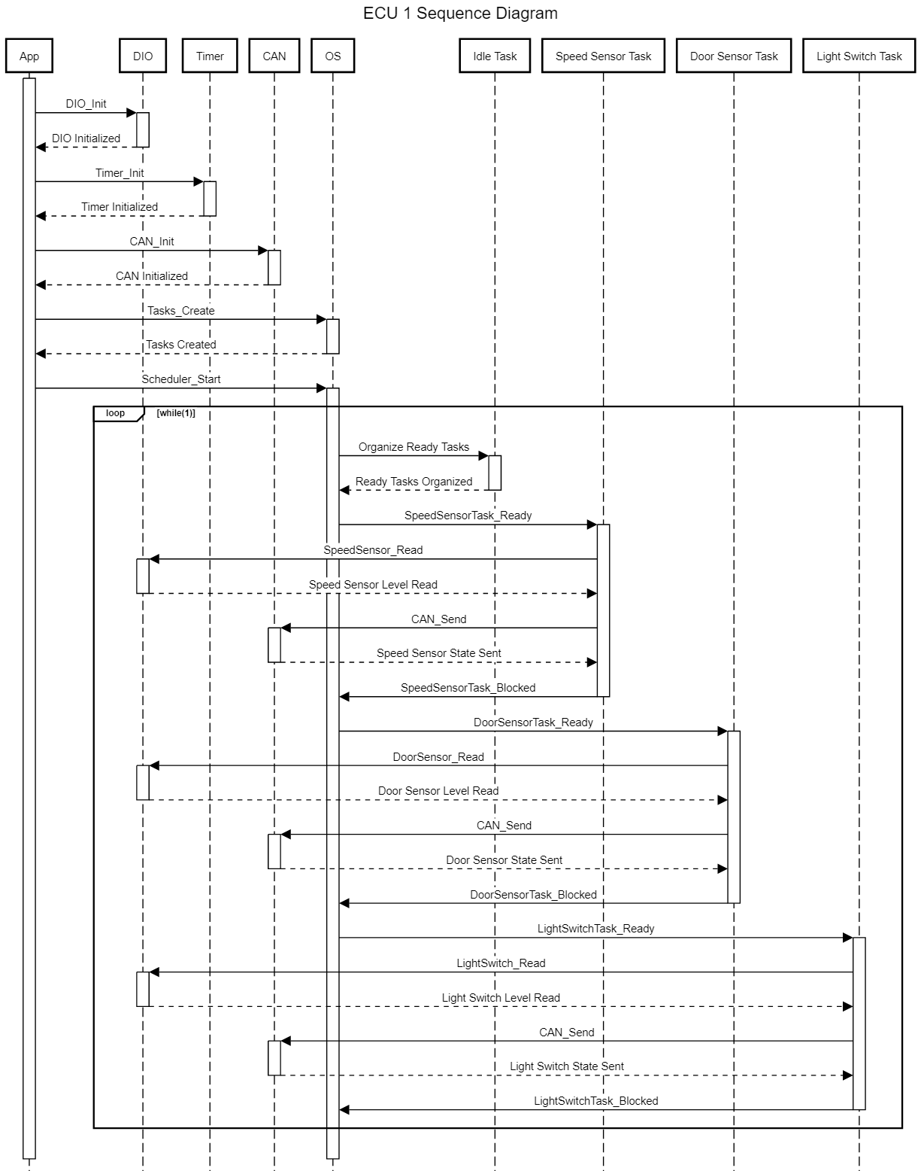“Draw the sequence diagram for the ECU.”*
* *“Calculate CPU load for the ECU.”*
* For each task, the input level is read using the DIO module. Assume that this process takes 3 assembly instruction with each instruction executed in 4 clock cycles.
* Afterwards, the message containing the input level is sent through the CAN bus to ECU 2. The CAN bus frame has 29 bits according to the CAN protocol v2.0B. Assume that the bit rate of the CAN communication is 500kb/sec.
* Assuming the clock frequency of the ECU is 1MHz, 1 clock cycle is equal to 1 microsecond:

1. Speed Sensor task is executed every 5 milliseconds 🡪

1. Door Sensor task is executed every 10 milliseconds 🡪
2. Light Switch task is executed every 20 milliseconds 🡪

* In total the CPU load of ECU 1 is $\left[{(14000+7000+3500)}/{1000000}\right]*100\%=2.45\%$

**For ECU 2:**

* *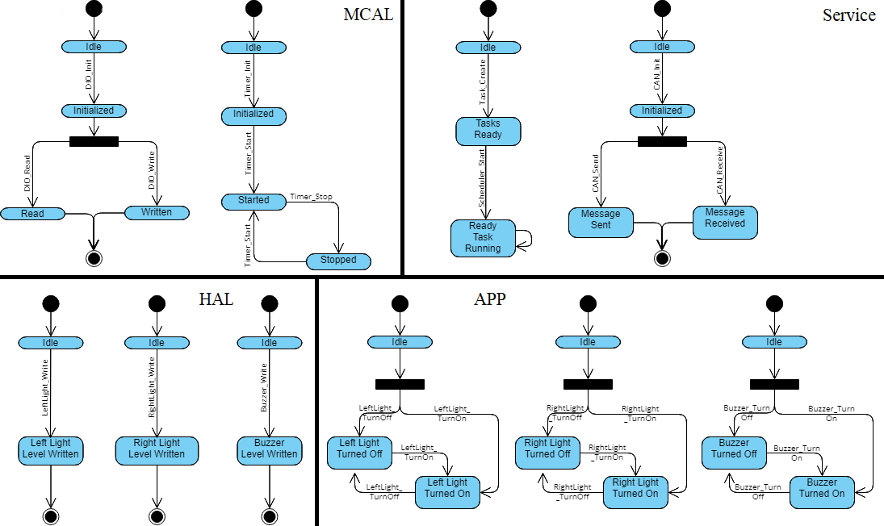“Draw a state machine diagram for each ECU component.”*
* *“Draw a state machine diagram for the ECU operation.”*

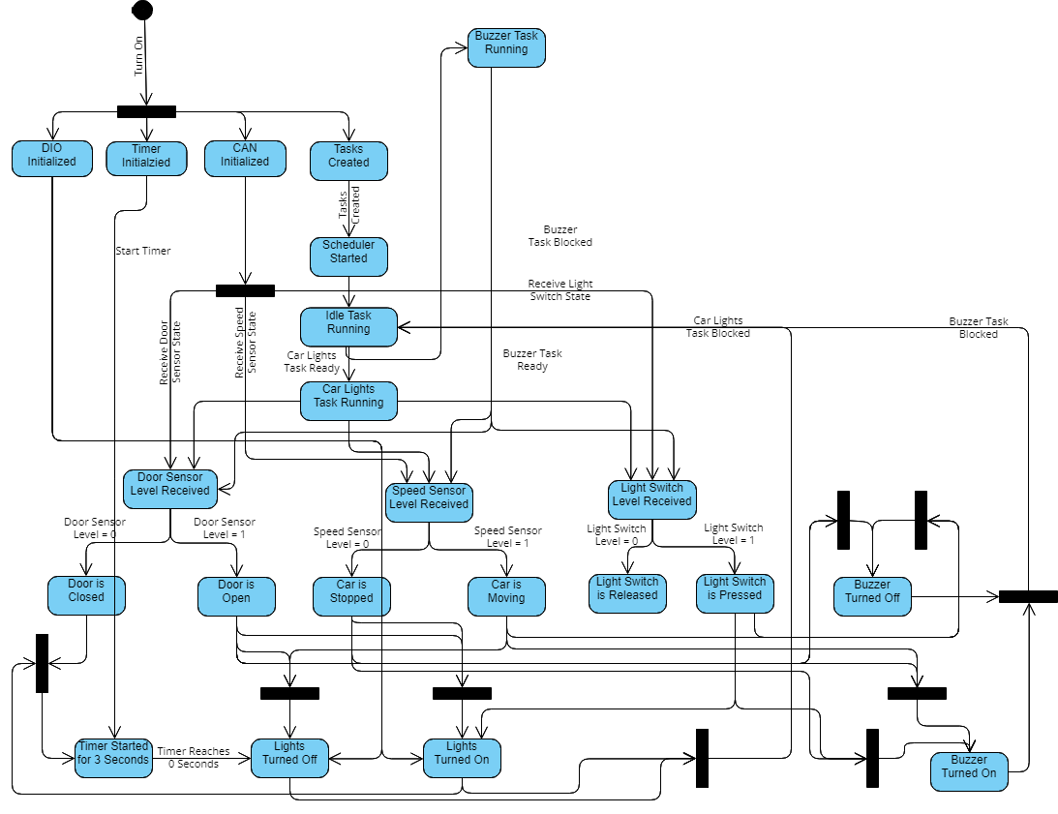

* *“Draw the sequence diagram for the ECU.”*

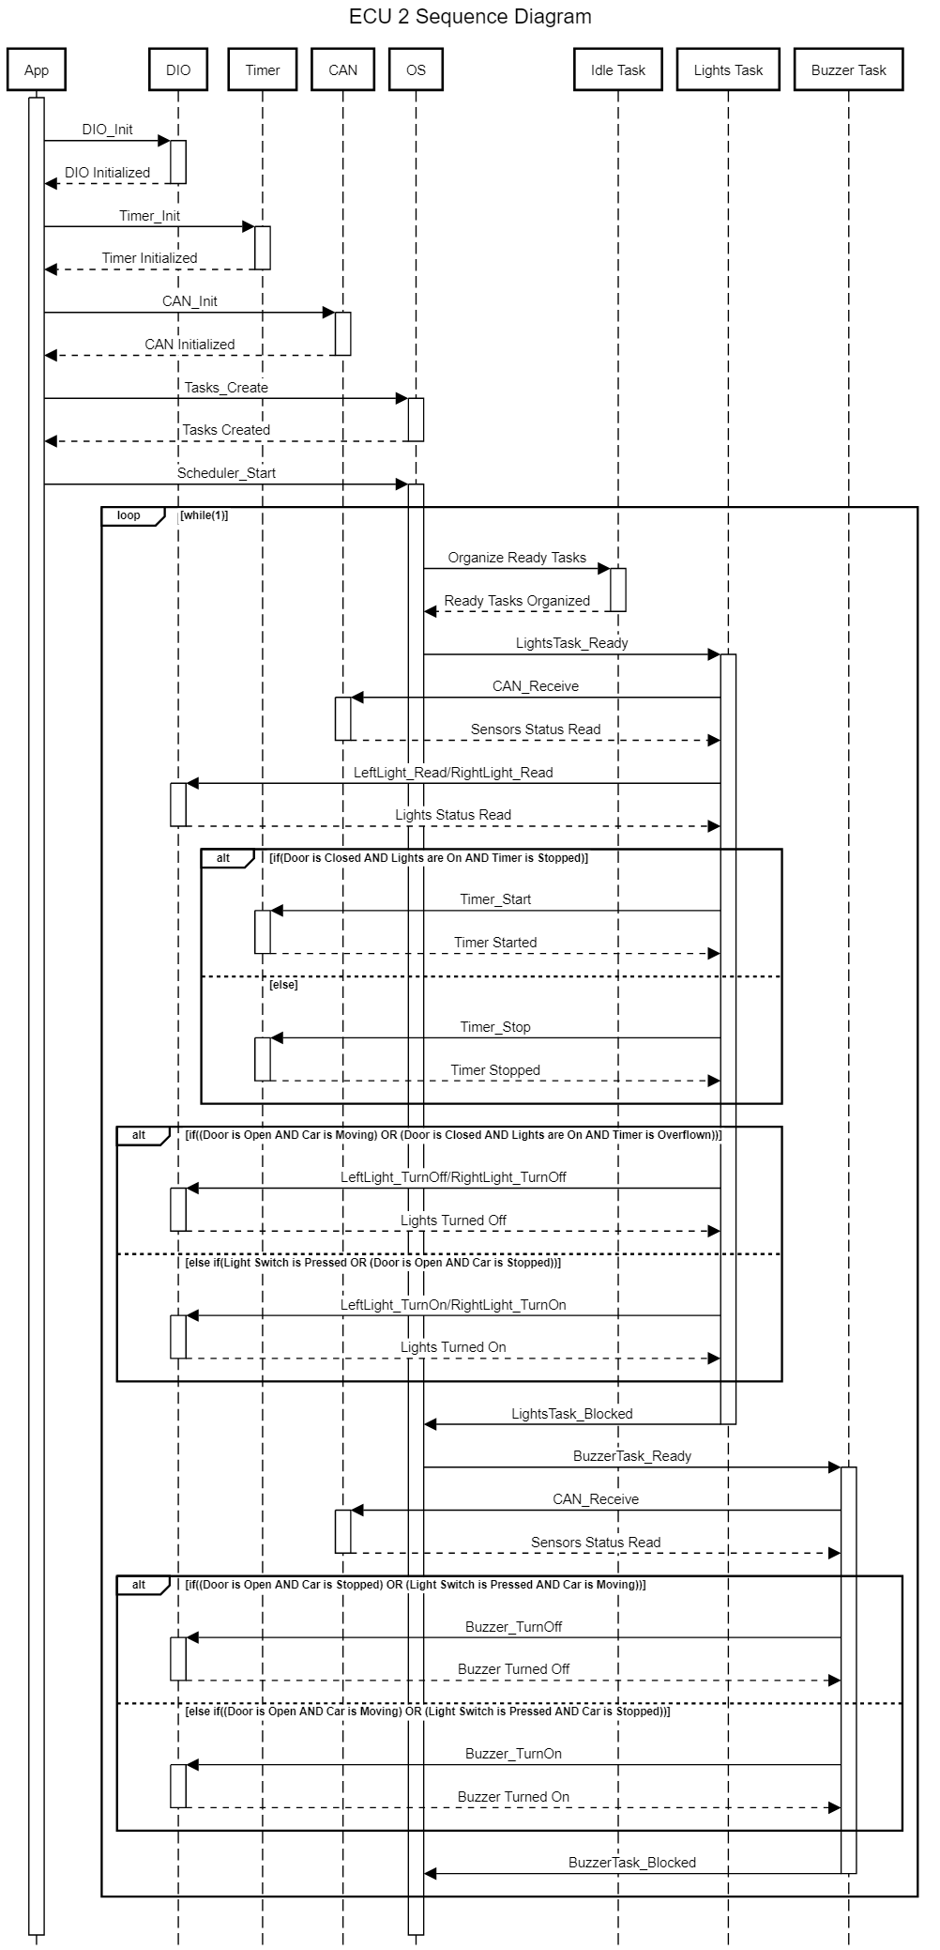

* *“Calculate CPU load for the ECU.”*
* For both tasks, the message containing the input levels is received through the CAN bus from ECU 1. The CAN bus frame has 29 bits according to the CAN protocol v2.0B. Assume that the bit rate of the CAN communication is 500kb/sec.
* For the Lights task, the lights levels are read using the DIO module. Assume that this process takes 3 assembly instruction with each instruction executed in 4 clock cycles. As for the timer module, Assume that setting or clearing the timer with the desired value takes 7 clock cycles.
* For both tasks, the if/else statements along with writing the values to the DIO module is assumed to take at most 14 clock cycles.
* Assuming the clock frequency of the ECU is 1MHz, 1 clock cycle is equal to 1 microsecond:

1. Lights task is executed every 5 milliseconds 🡪

1. Buzzer task is executed every 5 milliseconds 🡪

* In total the CPU load of ECU 1 is $\left[{(30800+22800)}/{1000000}\right]*100\%=5.36\%$